|  |  |  |  |
| --- | --- | --- | --- |
| |  |  | | --- | --- | | Communication Systems (2)  Faculty of Engineering  Ain Shams University  4th Year ECE Fall 2018 | ainshams.jpg | |  |

|  |  |
| --- | --- |
| **Communication Systems (2)**  **MATLAB ROJECT**  **(512 QAM Modulation)** | |
| Group: 14 | |
| **Student Name** | **Report Mark** |
| 1. أحمد أشرف محمد عبد الله |  |
| 1. عبد الرحمن مجدي محمد أحمد |  |
| 1. معاذ سعيد حسن |  |
| 1. أحمد عبد الجليل ابراهيم اسماعيل |  |
| 1. ساره خالد عبد العال |  |
| **#Delivery Date 20/12/2018** | |

***Mapping Code:***

clear all;

close all;

clc;

% We will use 512 QAM Modulation

% That means we have 512 symbols and #bits/symbols = log2(512) = 9

% our stream of bits at least will be 512 * 9 = 4608 bit

M = 512; % Number of symbols

m = log2(M); % Number Of bits per symbol

n_bits = 4608 ; % Defining Number of bits

stream = randi([0, 1], 1,n_bits); % This function generates 4608 random binary values

% Representation of transmitting binary information as digital signal

x=stream;

bp=.000001; % bit period

bit=[]; % Defining empty array

% The following for loop convert the stream of bits to a digital signal

for n=1:1:length(x)

if x(n)==1;

se=ones(1,100);

else x(n)==0;

se=zeros(1,100);

end

bit=[bit se];

end

t1=bp/100:bp/100:100*length(x)*(bp/100);

figure(1)

subplot(3,1,1);

plot(t1,bit,'lineWidth',2.5);grid on;

axis([ 0 bp*length(x) -.5 1.5]);

ylabel('amplitude(volt)');

xlabel(' time(sec)');

title('transmitting information as digital signal');

% binary information convert into symbolic form for M-array QAM modulation

stream_reshape=reshape(stream,log2(M),n_bits/log2(M))'; % Reshape every 9 bits into one vector

for(j=1:1:M)

for(i=1:1:log2(M))

a(j,i)=num2str(stream_reshape(j,i));

end

end

as=bin2dec(a);

ass=as';

figure(1)

subplot(3,1,2);

stem(ass,'Linewidth',2.0);

title('serial symbol for 512 QAM modulation at transmitter');

xlabel('n(discrete time)');

ylabel(' magnitude');

% Mapping for 512 QAM modulation

% define general constellation distribution for 512 QAM starting from 0 to 511

constellation = [-15+17i -15+19i -15+21i -15+23i -1+23i -1+21i -1+19i -1+17i -1-17i -1-19i -1-21i -1-23i -15-23i -15-21i -15-19i -15-17i -13+17i -13+19i -13+21i -13+23i -3+23i -3+21i -3+19i -3+17i -3-17i -3-19i -3-21i -3-23i -13-23i -13-21i -13-19i -13-17i -11+17i -11+19i -11+21i -11+23i -5+23i -5+21i -5+19i -5+17i -5-17i -5-19i -5-21i -5-23i -11-23i -11-21i -11-19i -11-17i -9+17i -9+19i -9+21i -9+23i -7+23i -7+21i -7+19i -7+17i -7-17i -7-19i -7-21i -7-23i -9-23i -9-21i -9-19i -9-17i -23+15i -23+13i -23+11i -23+9i -23+7i -23+5i -23+3i -23+1i -23-1i -23-3i -23-5i -23-7i -23-9i -23-11i -23-13i -23-15i -21+15i -21+13i -21+11i -21+9i -21+7i -21+5i -21+3i -21+1i -21-1i -21-3i -21-5i -21-7i -21-9i -21-11i -21-13i -21-15i -19+15i -19+13i -19+11i -19+9i -19+7i -19+5i -19+3i -19+1i -19-1i -19-3i -19-5i -19-7i -19-9i -19-11i -19-13i -19-15i -17+15i -17+13i -17+11i -17+9i -17+7i -17+5i -17+3i -17+1i -17-1i -17-3i -17-5i -17-7i -17-9i -17-11i -17-13i -17-15i -15+15i -15+13i -15+11i -15+9i -15+7i -15+5i -15+3i -15+1i -15-1i -15-3i -15-5i -15-7i -15-9i -15-11i -15-13i -15-15i -13+15i -13+13i -13+11i -13+9i -13+7i -13+5i -13+3i -13+1i -13-1i -13-3i -13-5i -13-7i -13-9i -13-11i -13-13i -13-15i -11+15i -11+13i -11+11i -11+9i -11+7i -11+5i -11+3i -11+1i -11-1i -11-3i -11-5i -11-7i -11-9i -11-11i -11-13i -11-15i -9+15i -9+13i -9+11i -9+9i -9+7i -9+5i -9+3i -9+1i -9-1i -9-3i -9-5i -9-7i -9-9i -9-11i -9-13i -9-15i -7+15i -7+13i -7+11i -7+9i -7+7i -7+5i -7+3i -7+1i -7-1i -7-3i -7-5i -7-7i -7-9i -7-11i -7-13i -7-15i -5+15i -5+13i -5+11i -5+9i -5+7i -5+5i -5+3i -5+1i -5-1i -5-3i -5-5i -5-7i -5-9i -5-11i -5-13i -5-15i -3+15i -3+13i -3+11i -3+9i -3+7i -3+5i -3+3i -3+1i -3-1i -3-3i -3-5i -3-7i -3-9i -3-11i -3-13i -3-15i -1+15i -1+13i -1+11i -1+9i -1+7i -1+5i -1+3i -1+1i -1-1i -1-3i -1-5i -1-7i -1-9i -1-11i -1-13i -1-15i 1+15i 1+13i 1+11i 1+9i 1+7i 1+5i 1+3i 1+1i 1-1i 1-3i 1-5i 1-7i 1-9i 1-11i 1-13i 1-15i 3+15i 3+13i 3+11i 3+9i 3+7i 3+5i 3+3i 3+1i 3-1i 3-3i 3-5i 3-7i 3-9i 3-11i 3-13i 3-15i 5+15i 5+13i 5+11i 5+9i 5+7i 5+5i 5+3i 5+1i 5-1i 5-3i 5-5i 5-7i 5-9i 5-11i 5-13i 5-15i 7+15i 7+13i 7+11i 7+9i 7+7i 7+5i 7+3i 7+1i 7-1i 7-3i 7-5i 7-7i 7-9i 7-11i 7-13i 7-15i 9+15i 9+13i 9+11i 9+9i 9+7i 9+5i 9+3i 9+1i 9-1i 9-3i 9-5i 9-7i 9-9i 9-11i 9-13i 9-15i 11+15i 11+13i 11+11i 11+9i 11+7i 11+5i 11+3i 11+1i 11-1i 11-3i 11-5i 11-7i 11-9i 11-11i 11-13i 11-15i 13+15i 13+13i 13+11i 13+9i 13+7i 13+5i 13+3i 13+1i 13-1i 13-3i 13-5i 13-7i 13-9i 13-11i 13-13i 13-15i 15+15i 15+13i 15+11i 15+9i 15+7i 15+5i 15+3i 15+1i 15-1i 15-3i 15-5i 15-7i 15-9i 15-11i 15-13i 15-15i 17+15i 17+13i 17+11i 17+9i 17+7i 17+5i 17+3i 17+1i 17-1i 17-3i 17-5i 17-7i 17-9i 17-11i 17-13i 17-15i 19+15i 19+13i 19+11i 19+9i 19+7i 19+5i 19+3i 19+1i 19-1i 19-3i 19-5i 19-7i 19-9i 19-11i 19-13i 19-15i 21+15i 21+13i 21+11i 21+9i 21+7i 21+5i 21+3i 21+1i 21-1i 21-3i 21-5i 21-7i 21-9i 21-11i 21-13i 21-15i 23+15i 23+13i 23+11i 23+9i 23+7i 23+5i 23+3i 23+1i 23-1i 23-3i 23-5i 23-7i 23-9i 23-11i 23-13i 23-15i 9+17i 9+19i 9+21i 9+23i 7+23i 7+21i 7+19i 7+17i 7-17i 7-19i 7-21i 7-23i 9-23i 9-21i 9-19i 9-17i 11+17i 11+19i 11+21i 11+23i 5+23i 5+21i 5+19i 5+17i 5-17i 5-19i 5-21i 5-23i 11-23i 11-21i 11-19i 11-17i 13+17i 13+19i 13+21i 13+23i 3+23i 3+21i 3+19i 3+17i 3-17i 3-19i 3-21i 3-23i 13-23i 13-21i 13-19i 13-17i 15+17i 15+19i 15+21i 15+23i 1+23i 1+21i 1+19i 1+17i 1-17i 1-19i 1-21i 1-23i 15-23i 15-21i 15-19i 15-17i];

p =[]; % Defining empty array

% mapping symbols to general constellation

for v = 1:1:512

for vv = 1:1:512

if ass(v) == vv-1

p = [p constellation(vv)];

end

end

end

scatterplot(p),grid on;

title('constellation diagram for 512 QAM');

scatterplot(constellation),grid on;

title('constellation diagram for 512 QAM');

%512 QAM modulation

RR=real(p)

II=imag(p)

sp=bp*9; %symbol period for 512 QAM

sr=1/sp; % symbol rate

f=sr*2;

t=sp/100:sp/100:sp; % time vector for each transmitted symbol

m=[];

for(k=1:1:length(RR))

yr=RR(k)*cos(2*pi*f*t); % inphase or real component

yim=II(k)*sin(2*pi*f*t); % Quadrature or imagenary component

y=yr+yim;

m=[m y];

end

tt=sp/100:sp/100:sp*length(RR); % time vector for all transmitted symbols

figure(1);

subplot(3,1,3);

plot(tt,m);

title('waveform for 512 QAM modulation acording to symbolic information');

xlabel('time(sec)');

ylabel('amplitude(volt)');

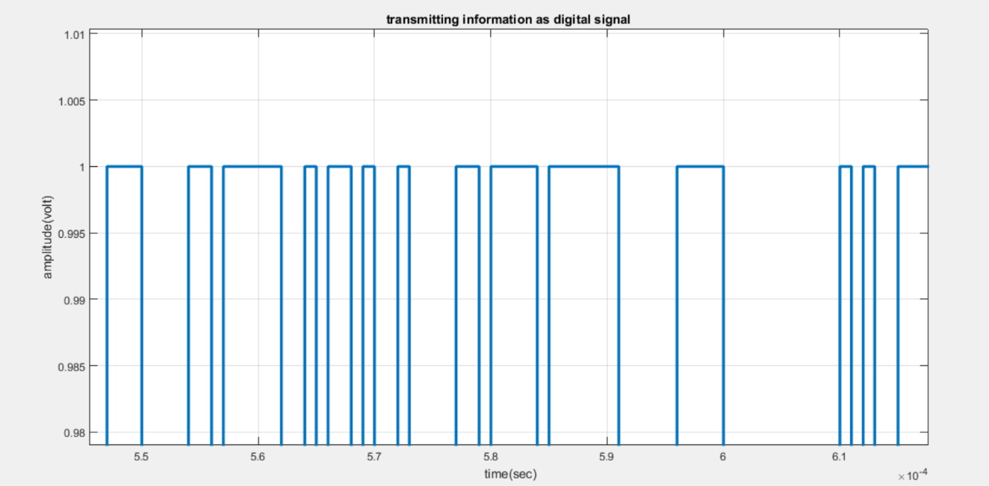***Digital Signal Representation Of The Random Sequence:***

***Comment***: Pulses here are NP-NRZ. “Zooming in” is achieved here to see a clear image. So zero at y-axis is not clear at this image.

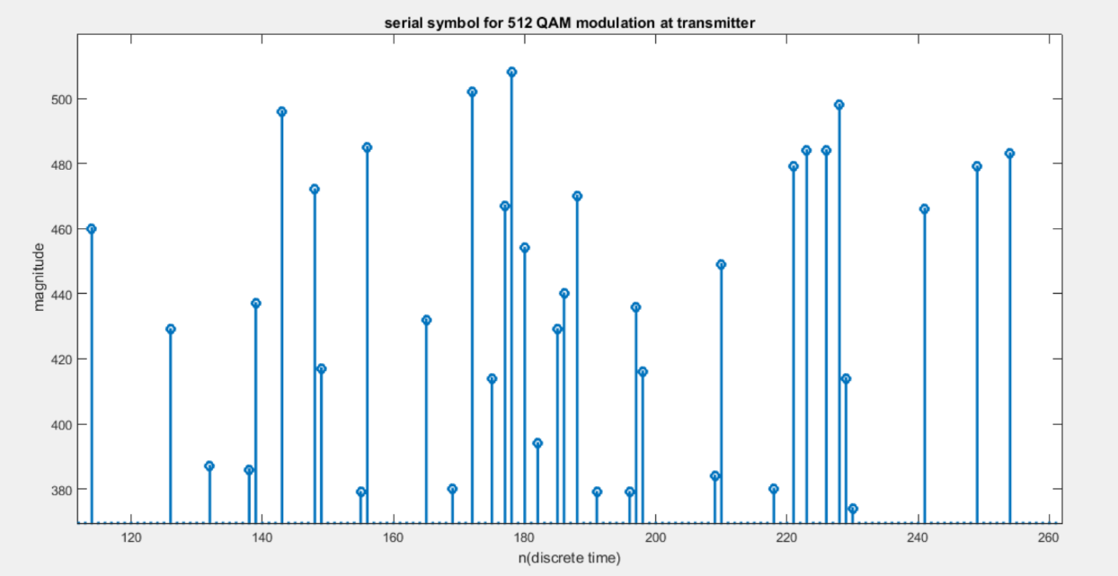***Serial Symbol For 512 QAM Modulation At Transmitter:***

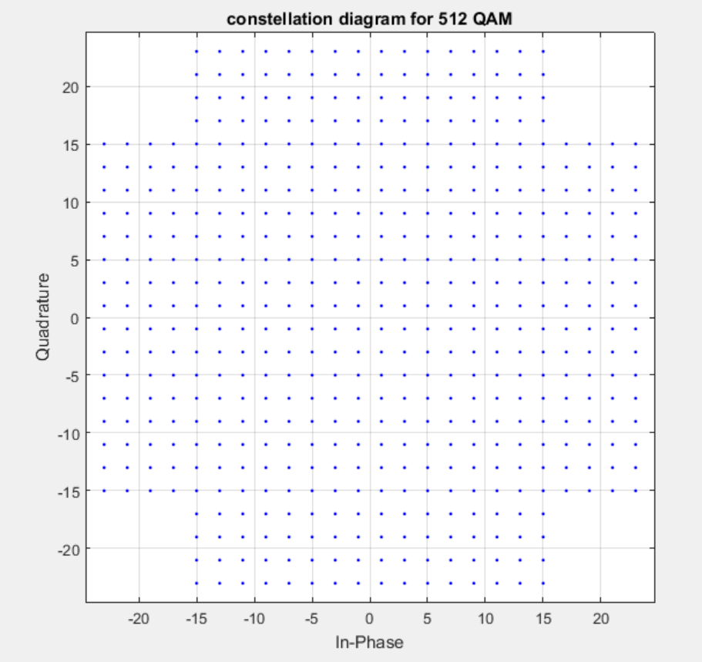***General Constellation Diagram For 512 QAM:***

***Comment:*** This is a general cross-shaped constellation diagram 512 QAM.

***Specific Constellation Diagram For Transmitted Symbols:***

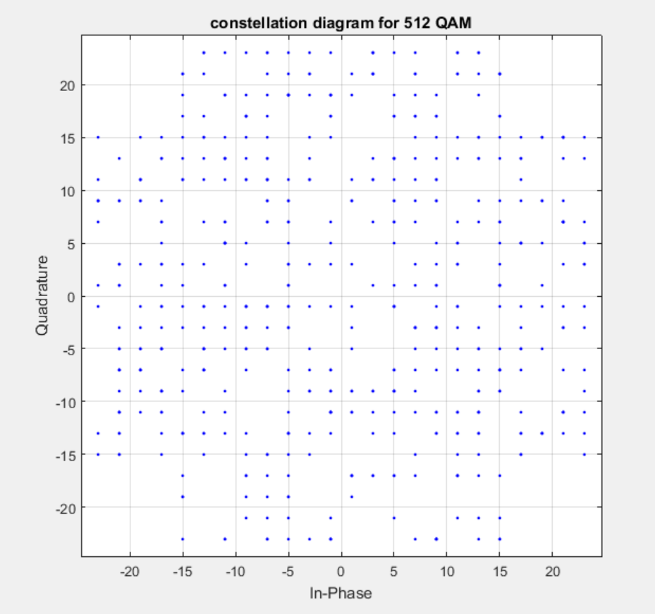

***AWGN Code:***

%AWGN channel

p_signal= mean(abs(y).^2); % signal power

% show noise effect on conestellation diagram

snr = 30; % signal to noise ratio in dB

noise = awgn(p,snr,'measured'); % awgn effect

h = scatterplot (noise);

grid

title('consttelation diagram for 512 QAM with AWGN(SNR=30)');

snr = 10;

noise = awgn(p,snr,'measured');

h = scatterplot (noise);

grid

title('consttelation diagram for 512 QAM with AWGN(SNR=10)');

snr = 5;

noise = awgn(p,snr,'measured');

h = scatterplot (noise);

grid

title('consttelation diagram for 512 QAM with AWGN(SNR=5)');

snr = 0;

noise = awgn(p,snr,'measured');

h = scatterplot (noise);

grid

title('consttelation diagram for 512 QAM with AWGN(SNR=0)');

snr = -3;

noise = awgn(p,snr,'measured');

h = scatterplot (noise);

grid

title('consttelation diagram for 512 QAM with AWGN(SNR=-3)');

***AWGN effect on the transmitted signal***

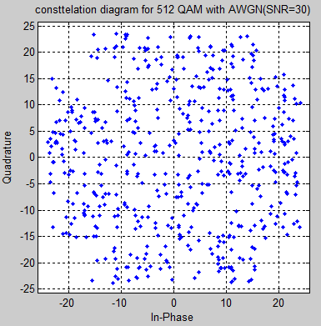

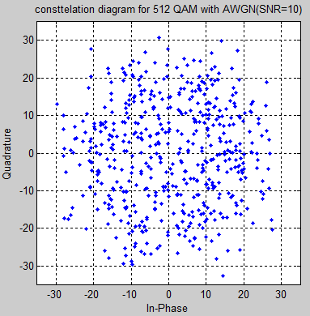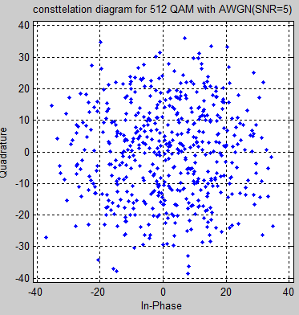

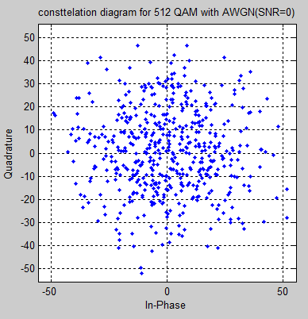

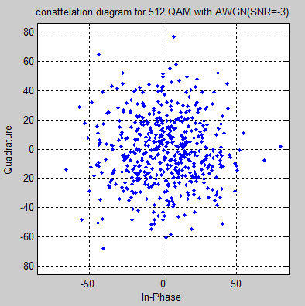

**Comment:** decreasing SNR (dB) means that the noise power is getting increase as {$SNR\left(dB\right)= \log_{10}\left(Ps\right)-\log_{10}\left(Pn\right)$} so the signal will be highly distorted and will be hard to detect it at the receiver.

Demapping and BER code:  
1st code:  
%% 512 QAM demodulation

clear i

clear j

k1 = floor(sqrt(M));

r = 2*(0:k1-1) - k1 + 1;

[xi, yi] = meshgrid(r);

c = xi + j*flipud(yi);

c = c(:);

%now comparing the data from c's vector after rounding the input data.

z = zeros(size( noise));

%Find closest constellation symbol, symbol-by-symbol.

for k1 = 1:length( noise)

[nil,ind] = min(abs( noise(k1) - c));

z(k1) = ind - 1;

end

zb=de2bi(z,'left-msb'); % converting from decimal to binary symbol

zb=reshape(zb.',numel(zb),1'); % converting symbol to vector of bits 0s and 1s

%%%%%%%%%%%%%%%%%%%%%%%%%%%%%%%%%%% BER

ber=0;

for i=1:length(stream)

if stream(i)~=zb(i)

ber=ber+1;

end

end

EbNoindB=-10:5:20;

EbNo=20;

noise1 = awgn(p,EbNo,'measured');

clear i

clear j

k11 = floor(sqrt(M));

rr = 2*(0:k11-1) - k11 + 1;

[xi, yi] = meshgrid(rr);

cc = xi + j*flipud(yi);

cc = cc(:);

%now comparing the data from c's vector after rounding the input data.

zz = zeros(size(noise1));

%Find closest constellation symbol, symbol-by-symbol.

for k11 = 1:length(noise1)

[nill,indd] = min(abs(noise1(k11)-cc));

zz(k11)= indd- 1;

end

zbb=de2bi(zz,'left-msb'); % converting from decimal to binary symbol

zbb=reshape(zbb.',numel(zbb),1'); % converting symbol to vector of bits 0s and 1s

ber1=0;

for i=1:length(stream)

if stream(i)~=zbb(i)

ber1=ber1+1;

end

end

BER=[2243 2210 2086 2076 2036 1984 1946];

BER1=BER/n_bits;

semilogy(EbNoindB,BER1)

title('the relation between the BER vs. Eb\NoindB');

xlabel('Eb\NoindB');

ylabel('bit_error_rate');

EbNoratio=10.^(EbNoindB/10);

q=sqrt((3/2)*EbNoratio.*(9/(M-1)));

Pe=(2/9)*(1-1/sqrt(M)).*erfc(q);

figure

semilogy(EbNoindB,Pe)

title('the relation between theortical BER vs. Eb\NoindB');

xlabel('Eb\NoindB');

ylabel('bit_error_rate');

2nd code:  
cii= -24:2:24;

bii= -24:2:24;

cii = cii(cii~=0);

bii = bii(bii~=0);

con_phii=cii+1i*bii;

con2=[];

for iii=1:1:24

for jj=1:1:24

con3(jj)=cii(iii)+1i*bii(jj);

end

con2=[con2 con3];

end

pp=[];%empty array

for c = 1:1:512

for cc = 1:1:512

if ass(c) == cc-1

pp = [pp con2(cc)];

end

end

end   
%%detect symbol

SS=zeros(size(noise1));

for kkk=1:1:512

if (real(noise1(kkk))> 0) && (imag(noise1(kkk))> 0)

for mu11=2:2:24

if (real(noise1(kkk))<mu11)

for mu21=2:2:24

if (imag(noise1(kkk))<mu21)

for e=1:1:512

if abs(noise1(kkk))<=abs(pp(e))&&...

abs(mu11+1i*mu21)==abs(pp(e))

SS(e)=ass(e);

end

end

if (mu21)<(mu21+2)

break

end

end

end

if (mu11)<(mu11+2)

break

end

end

end

elseif (real(noise1(kkk))> 0) && (imag(noise1(kkk))< 0)

for mu12=2:2:24

if (real(noise1(kkk))<mu12)

for mu22=-2:-2:-24

if (imag(noise1(kkk))>mu22)

for e=1:1:512

if abs(noise1(kkk))<=abs(pp(e))&&...

abs(mu12+1i*mu22)==abs(pp(e))

SS(e)=ass(e);

end

end

if (mu22)>(mu22-2)

break

end

end

end

if (mu12)<(mu12+2)

break

end

end

end

elseif (real(noise1(kkk))< 0) && (imag(noise1(kkk))> 0)

for mu13=-2:-2:-24

if (real(noise1(kkk))>mu13)

for mu23=2:2:24

if (imag(noise1(kkk))<mu23)

for e=1:1:512

if abs(noise1(kkk))<=abs(pp(e))&&...

abs(mu13+1i*mu23)==abs(pp(e))

SS(e)=ass(e);

end

end

end

if (mu23)<(mu23+2)

break

end

end

if (mu13)>(mu13-2)

break

end

end

end

elseif (real(noise1(kkk))< 0) && (imag(noise1(kkk))< 0)

for mu14=-2:-2:-24

if (real(noise1(kkk))>mu14)

for mu24=-2:-2:-24

if (imag(noise1(kkk))>mu24)

for e=1:1:512

if abs(noise1(kkk))<=abs(pp(e))&&...

abs(mu14+1i*mu24)==abs(pp(e))

SS(e)=ass(e);

end

end

if (mu24)>(mu24-2)

break

end

end

end

if (mu14)>(mu14-2)

break

end

end

end

else

end

end

SS1=SS';

ss=dec2bin(SS');

for jo=1:1:M

for ko=1:1:m

data_symbol_out(jo,ko)= str2num(ss(jo,ko));% stream of bits to string

end

end

data_out = reshape(data_symbol_out,n,1);

ber=0;

for i=1:length(stream)

if stream(i)~=data_out(i)

ber=ber+1;

end

end

EbNoindB=-10:5:20;

BER=[2243 2210 2086 2076 2036 1984 1946];

BER1=BER/n_bits;

semilogy(EbNoindB,BER1)

title('the relation between the BER vs. Eb\NoindB');

xlabel('Eb\NoindB');

ylabel('bit_error_rate');

%%%%%%%%%%%%%%%%%%%%%%%%%%%%%%%%%%%%%%%%%%%%%%%%%%%%%%%%%%%%%%%%%5

EbNoratio=10.^(EbNoindB/10);

q=sqrt(3*9*EbNoratio/(M-1));

PE=(4/9)*(1-1/sqrt(M))*(1/2)*erfc(q/sqrt(2));

figure

semilogy(EbNoindB,PE)

title('the relation between theortical BER vs. Eb\NoindB');

xlabel('Eb\NoindB');

ylabel('bit_error_rate');  
  
Plot the relation between the BER vs. Eb/No in dB:  
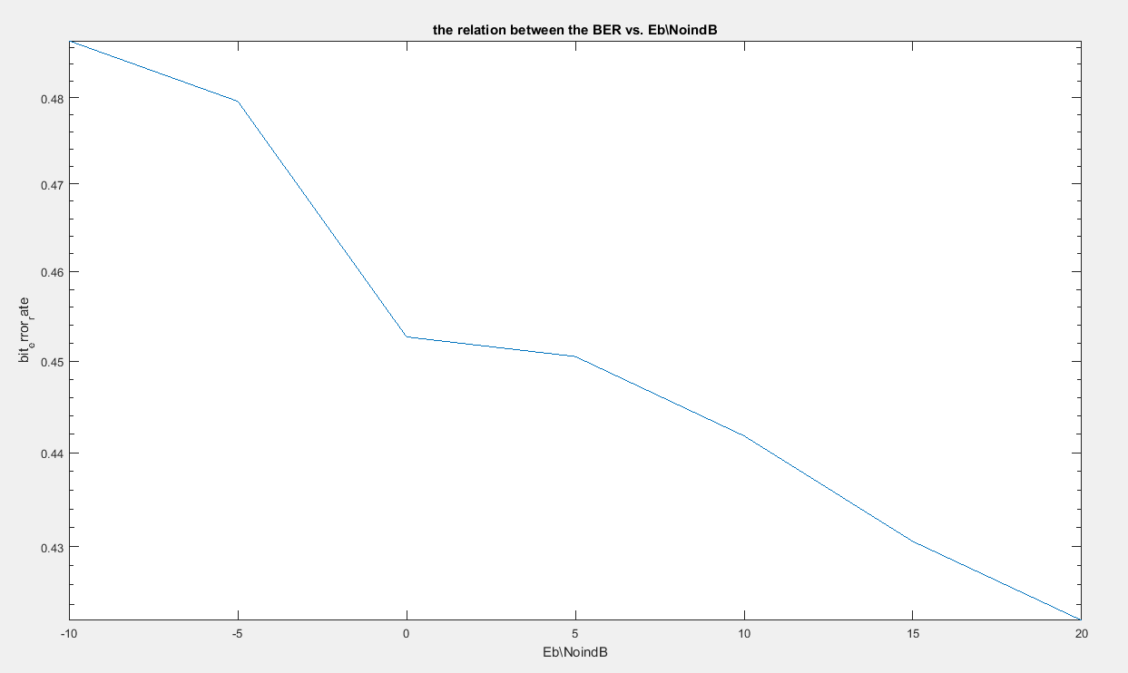

Plot the theoretical relation between BER and Eb/No indB :  
